**Glue HERE on Syllabus and**

**Notebook Expectation Page**

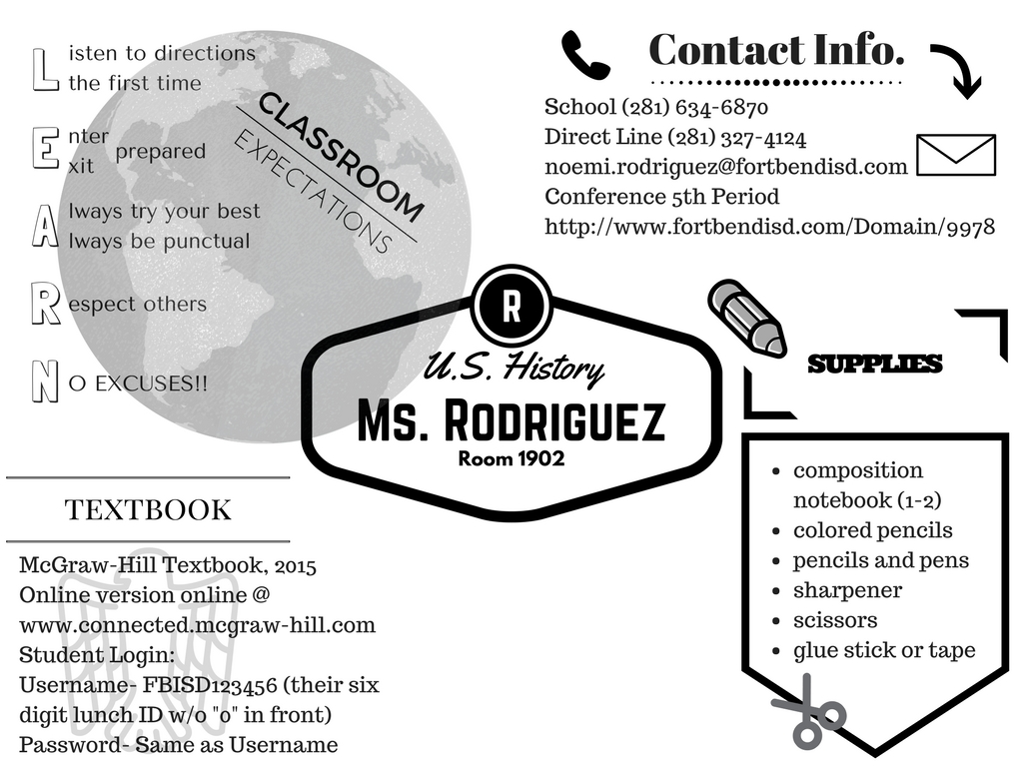

**United States History Until 1877**

|  |  |  |  |
| --- | --- | --- | --- |
| ***First Semester*** | | ***Second Semester*** | |
| **1st Nine Weeks** | **2nd Nine Weeks** | **3rd Nine Weeks** | **4th Nine Weeks** |
| * Exploration and discovery * Colonization/Colonial Life * Revolution in The Colonies | * Creating a Republic * The U.S. Constitution & New Republic * Review & Semester Exams | * New Republic (con.) * America Transforming: Prosperity and Democracy * America Transforming: Expansion & Sectionalism | * America Transforming: Expansion & Sectionalism (con.) * Causes of the Civil War/The Civil War * STAAR Enrichment and Testing * Intro to Geography of the United States * Review /Semester Exams |

**Grades:**

Students will be given assignments in class, and will be made aware of all tests, projects, and quizzes. All major assignments and project rubrics will be reviewed in class and then posted on my teacher webpage.

|  |  |
| --- | --- |
| **Daily grades** (8-12 per 9 weeks)  ½ of a student’s overall average.  Daily grades include homework,  classwork, quizzes, notebook grades,  worksheets, etc. | **Major grades** (3-4 per 9 weeks)  ½ of a student’s overall average.  Major grades include tests and projects |

**Homework:**

Students will be assigned homework for practice and to prepare for tests and quizzes. It is the student’s responsibility to write down any and all assignments and their due dates in their planners.

**Make-Up Work:**

When a student is absent, it is *THE RESPONSIBILITY OF THE STUDENT* to obtain and complete any missed work, notes, or assignments. Students should check the “absent box” for any missed handouts.

**Late Work:**

Students who fail to turn in work on the due date will lose points as per the BMS and FBISD late work policy. This policy will be thoroughly explained in class. In addition, students will be assigned the next available “working lunch” as per the BMS handbook. Late work will be accepted with point deductions as follows:

**1st day late: -10 points**

**2nd day late: -20 points**

**3rd day late: -30 points**

**This is BMS school policy.** Parents will NOT be contacted for missing or late daily assignments. Parents will be phoned or emailed if a major grade assignment is more than one day late. Please ask for clarification if you have any questions about the late work policy.

**Extra Help?**

If a student is having trouble, they should speak with Ms. Rodriguez as soon as possible. The teacher will work with the student to schedule a time for tutorials. Students should ALWAYS inform Ms. Rodriguez if they are planning on coming before or after school to ensure she is available.

**Grading Scale**

A= 90-100 B=80-89 C=70-79 F= 69 and below